Name: _______________________________ Date: ________________

The Munich News
The Appeasement Issue
September 1938

Only
.25
Cents

Only
.25
Cents

Trouble in Munich!

Munich Conference-

The Weekly Word
Appeasement-

What is up in the Sudetenland?
Sudetenland-

In today’s issue we have some of the most entertainingly funny, descriptive, and informing political cartoons ready for you to view. Each representing things we have learned and read about today. Study the cartoons carefully and answer the questions that follow.

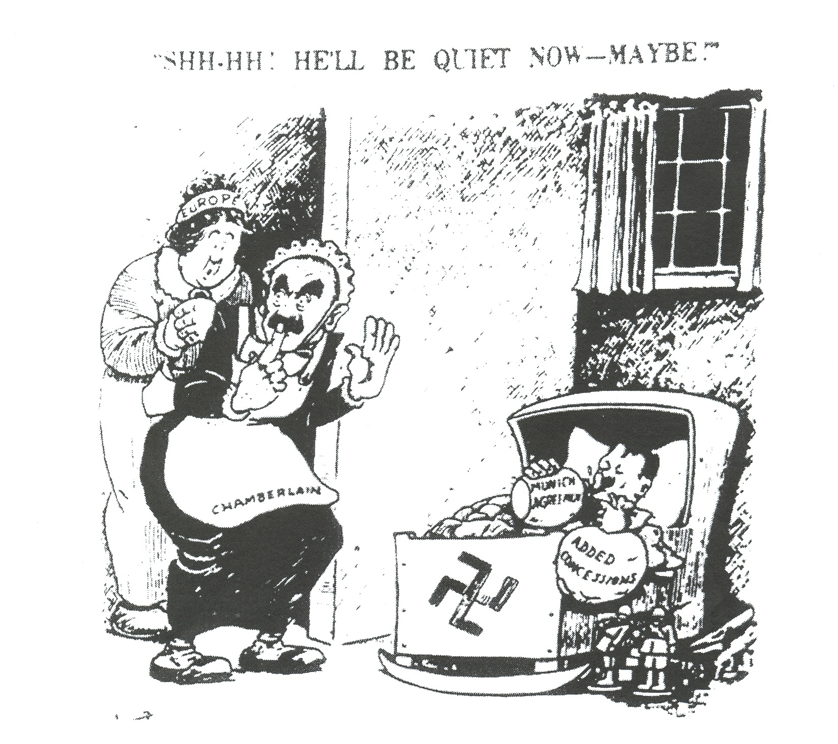
The Munich News
September 1938

Cartoon #1

Questions

- Who are the two figures dressed as nursemaids?

- Who is the “baby” in the cradle?

- What does the bottle symbolize?

- What does the cartoonist imply will happen when the baby has finished its bottle?
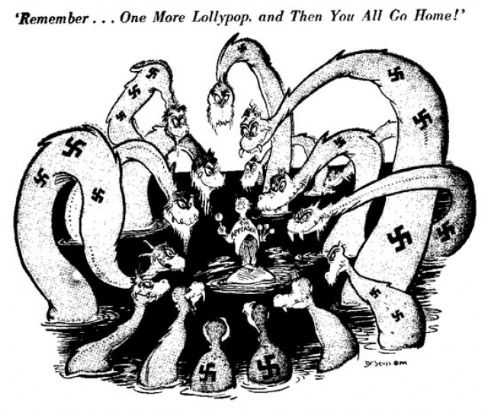
Cartoon #2
The Munich News
September 1938

Questions
- Who do the monsters represent?

- Who is “the appeaser” representing?

- Does the “lollypop” satisfy the monsters? Explain.

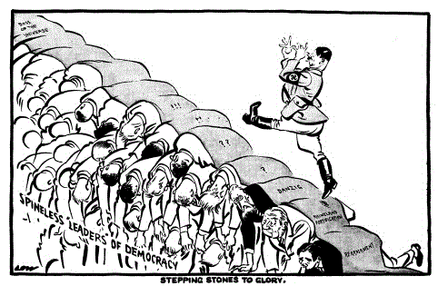
Cartoon #3

Questions
Who
- Who is the man walking?

- What is he walking on?
The Munich News
September 1938

- What is the meaning of the cartoon above?

- Give this article a title?
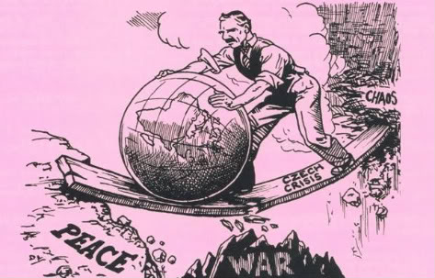
Questions
The Munich News
September 1938

Cartoon #4

- What event does the cartoon refer to?

- Who is the man in this cartoon?

- What is the symbolism of the globe?

- What is the message of this cartoon?

